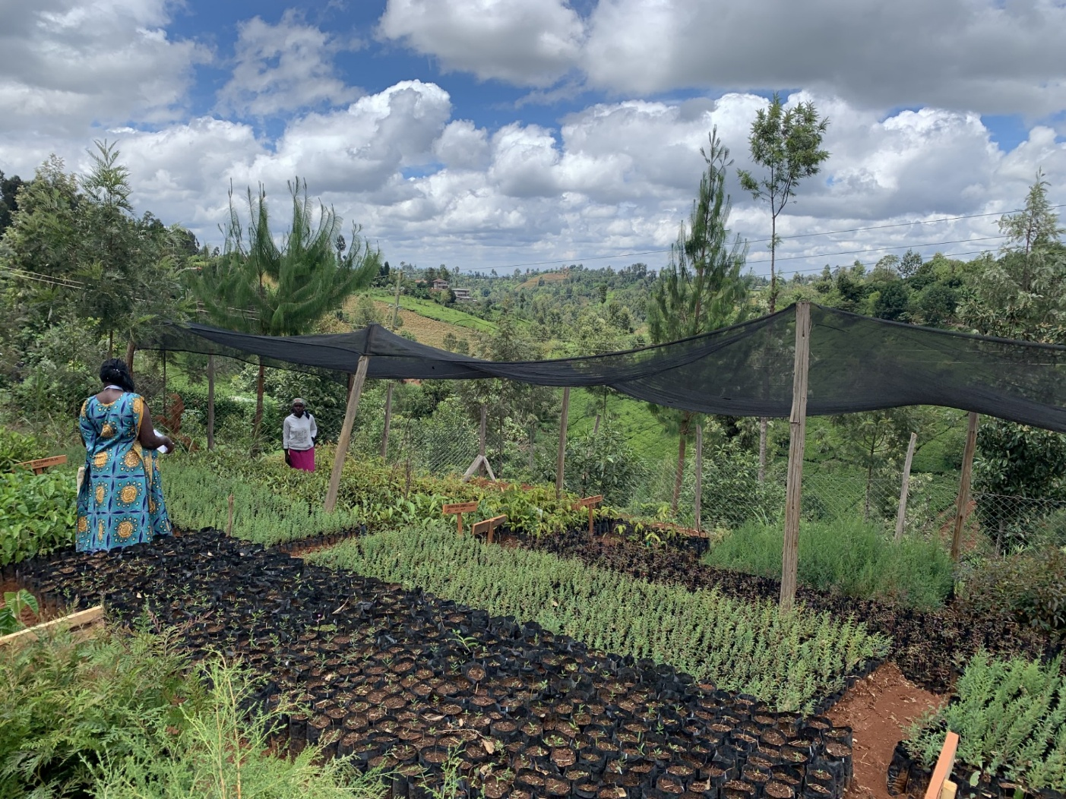

Collective Organisation Maturity
Evaluation Tool (COMET)
A toolkit for forest and farm producer organisations — assessment framework

Duncan Macqueen

April 2026

How to use the COMET assessment framework
The COMET assessment framework presented here accompanies the toolkit, Collective Organisation Maturity Evaluation Tool (COMET): a toolkit for forest and farm producer organisations.
The purpose of the COMET toolkit is to provide a quick and easy assessment of organisational maturity with credible accuracy. The assessment can be conducted internally as a self-assessment, or by an external reviewer such as a member of an apex organisation, a project facilitator or a paid consultant.
The toolkit and template were prepared for the Forest and Farm Facility (FFF), a partnership of the Food and Agriculture Organization of the United Nations (FAO), International Union for Conservation of Nature (IUCN), AgriCord and IIED.

Step 1. Complete the assessment framework questions
The COMET assessment framework draws on key indicators to assess maturity in the following five key areas:
- Internal organisational governance
- Environmental sustainability
- Business development
- Financial management
- Social inclusion

For each of these five areas, there are five indicator questions to assess maturity, each with four possible states of maturity that can be scored from 1 to 4. The assessment framework uses the following maturity categories:

- Nascent (baseline): isolated individual producers with little formal collective action beyond traditional authority structures.
- Emergent: ad hoc producer groups in the initial stages of defining their objectives and how to deliver them sustainably.
- Advancing: formalising producer groups that have planned structures, operational policies and operational practices but without tested delivery.
- Mature: professionalised producer groups with well-tested structures, policies and practices that are delivering members’ objectives sustainably.

Step 2. Enter the assessment framework scores into a spider diagram
Once you have scored the five areas of organisational functionality in Step 1 (each out of 20), the five totals can be summed to give a score out of 100. The next step is to enter the scores into a spider diagram using the template provided. The diagram helps to show which areas of your organisation are strong or weak.

Step 3. Write an organisational stocktake and improvement plan
Together, the scores and spider diagram give a snapshot of your organisation’s maturity at a given moment. You can then use this assessment data to write an organisational stocktake and improvement plan, describing your organisation’s priority areas for improvement.

Step 1. Assessment framework questions

1.1 Assessment of organisational governance and relationships
The following questions aim to assess how the organisation is structured and run and how it works with others. It includes who leads, how decisions are made, how work is checked, and making sure the organisation follows rules and standards.
Maturity status | Nascent | 1 | Emergent | 2 | Advancing | 3 | Mature | 4 | Sum
A. Organisational governance and relationships | Unorganised producers |  | Informal groups with ad hoc leadership |  | Formalised groups with governance and operating plans |  | Professionalised groups with board, management and separate departments
A1. What organisational structure is in place? | No membership, structure or leadership |  | Informal leadership over group of unquantified members |  | Salaried management structure and registered membership. |  | Board overseeing salaried leadership team, with an organogram of departmental management with registered membership
A2. What internal policies are in place? | No policies or documentation |  | Founding documents and objectives only |  | Negotiated bylaws and some operational plans and procedures |  | Detailed departmental policies, plans, quality standards and reports including on gender equality and safeguarding
A3. What management practices are in place? | No management practices |  | Regular meetings with >50% member attendance but leader-dominated |  | Routine meetings with >75% member attendance, defined staff positions and responsibilities |  | Trained and rotating management staff, routine meetings and departmental procedures, grievance mechanism, mentoring of other groups
A4. What legal status is in place? | Non-existent |  | Unregistered but locally known |  | Legally registered but still working on compliance |  | Legally registered with product and service compliance
A5. What political relationships are in place? | None |  | Invited to externally defined dialogues |  | Proactive and formally positioned involvement in (mostly sub-national) policy dialogues |  | Proactive and formally positioned involvement in policy dialogue processes at national or global level

Total organisational governance score out of 20:
Notes:

1.2 Assessment of environmental management and sustainability
The following questions assess the degree to which the organisation can help its members plan and manage natural resources in ways that are climate-resilient, regenerative and fair. This involves issues of biodiversity management, environmental sustainability and climate change mitigation, adaptation and resilience.
Maturity status | Nascent | 1 | Emergent | 2 | Advancing | 3 | Mature | 4 | Sum
B. Environmental management and sustainability | Traditional, individually controlled land-management practices |  | Collective efforts to source or manage resources |  | Collective sustainability efforts in planned land use |  | Advanced certified sustainability management
B1. What climate-resilient measures are practiced? | Awareness of climate threat |  | Training in climate resilience and members adopting >2 practices |  | Demonstration plots and training for several years with members adopting >3 practices |  | Formal climate-resilience plans and demonstration plots and training sustain production in face of change
B2. What input supply is in place? | Individually sourced seed and inputs |  | Collective external sourcing of seed, fertiliser and pesticides |  | Managed seedbanks and nurseries, and production of fertiliser and pesticide |  | Organically managed seedbanks and nurseries, production of biofertiliser and biopesticide
B3. What sustainability measures are in place? | Traditional farming methods |  | Limited awareness of land and soil restoration and agroecological methods |  | Aware of and partially applying restorative agroecological methods |  | Certified sustainability compliance using external certification or locally focused quality assurance systems such as participatory guarantee systems (PGS)
B4. What biodiversity practices are in place? | No formal biodiversity management |  | Primarily cash monocrops plus subsistence crops |  | Diversified crops for several markets from agroforestry systems |  | Multi-tiered agroforestry products targeting certified sustainability markets
B5. What soil and carbon conservation happens? | No quantified soil or carbon management |  | Basic awareness of soil fertility and carbon management but no structured conservation practices |  | Actively considering soil conservation and soil and tree carbon storage |  | Advanced protocols and regular assessment of soil and carbon storage

Total environmental management score out of 20:
Notes:

1.3 Assessment of economic entrepreneurship and viability
The following questions assess the degree to which the organisation forms, researches and develops viable value propositions and management structures, and invests in production qualities and efficiencies in ways that ensure profitability. This involves issues of market analysis, value creation and customer segmentation, attraction and retention.
Maturity status | Nascent | 1 | Emergent | 2 | Advancing | 3 | Mature | 4 | Sum
C. Economic entrepreneurship and viability | Individuals selling to local markets or market intermediaries |  | Collective group but still variable product quality and individual sales |  | Collective group with market research and sales to segmented customers |  | Integral market strategy responding to customer need via latest technology
C1. What market analysis and development are in place? | No market analysis or development |  | Individual ad hoc sales to segments of unresearched market |  | Researched market with business plan for collective customer sales |  | Market research informs evolving business plans and many repeat customer sales
C2. What production management is in place? | No production records or management |  | Unpredictable seasonal product volumes, no alternative supply, some production records |  | Managed production stocks with backup suppliers for stability and routinely updated production records |  | Stable managed production with formal growth strategy and backup suppliers, backed by computerised production records
C3. What quality standards and customer satisfaction surveys are in place? | No quality standards or customer research |  | Individual and variable quality standards and customer relations |  | Quality standards are in place, based on customer, national or industry standards for given commodity |  | Product brand and quality are continually upgraded in responce to customer feedback, national standards, production improvements
C4. What cost and break-even projections are in place? | Costing determined by traders, profitability and break-even unknown |  | Arbitrary costing or basic profitability analysis but without planned break-even |  | Regular market and internal cost setting with break-even analysis but few internal investment funds |  | Fully profitable, with full industry-standard costing and profit margin analysis and reinvestment of a part of revenues
C5. What technological advances are in place? | Largely manual labour with little or no value addition |  | Inefficient value-added processing/  marketing technology |  | Considered, efficient technology based on market trend analysis |  | Class-leading technology behind flagship product brand and network

Total economic entrepreneurship score out of 20:
Notes:

1.4 Assessment of financial accountability and transparency
The following questions assess the degree to which monetary resources of the organisation are managed transparently and deployed accountably and efficiently towards objectives. This involves issues of financial management, including the planning, control and analysis of income and expenditure, cash flow, profit and loss, and return on investment. It also includes the management of savings and loans funds on behalf of members.
Maturity status | Nascent | 1. | Emergent | 2. | Advancing | 3. | Mature | 4. | Sum
D. Financial transparency and accountability | Individuals with domestic finance only |  | Limited group accounting, income and savings |  | Professional accounts, income diversification, substantial savings |  | Digitised professional accounts and advanced internal savings and loans
D1. What financial records are monitored and disclosed? | No financial records |  | Group bank account and records kept but no financial statements |  | Regular financial statements presented at management meetings |  | Consistent software-based financial statements shared and used in inclusive decision-making
D2. What auditing and compliance are happening? | No checks or audits |  | Financial records kept by staff but not audited |  | Financial records kept by qualified accounting staff and checked internally |  | Digitised financial records kept by accounting staff and audited by external firm
D3. What revenue streams or sources of income are in place? | Mainly subsistence with few income sources or boom-and-bust projects |  | One main value chain generating income with associated costs |  | At least two sources of income and costs tracked by accountant |  | Three or more sources of income and cost tracked by digitised finances
D4. What liquidity, savings or loans are being used? | Household savings only |  | Limited group internal savings and no external credit or only risky money-lender credit |  | Groups savings backed by external loans from reliable sources to cover timely payments |  | Advanced internal finance services offering savings and credit, as well as access to reliable external credit
D5. What profitability is being achieved? | Unknown |  | Net surplus relative to costs is calculated and profits are stable at 10% |  | Turnover and profits tracked are greater than 10% and increasing |  | Turnover and profits growing healthily at 20% or above

Total financial accountability score out of 20:
Notes:

1.5 Assessment of social inclusion and protection
The following questions assess the degree to which everyone (women and men, youth and the elderly, ethnic groups) is treated fairly, and feels included and supported — especially people who are often left out. It covers how members’ rights are respected, how people can take part in decisions, and how benefits are shared so the whole community can thrive.

Maturity status | Nascent | 1. | Emergent | 2. | Advancing | 3. | Mature | 4. | Sum
E. Social inclusion, protection and solidarity
E1. What land and resource rights exist? | Traditional land rights |  | Group affirms traditional land and resource right claims |  | Group actively advances land and resource rights advocacy and titling |  | Group supports land and resource rights policies related to gender, youth and marginalised land; has resource and labour policies
E2. What social inclusion practices are in place? | Traditional cultural practices |  | Open membership and benefits for men, women, youth and ethnic groups |  | Affirmative action to encourage women, youth and ethnic participation, leadership and fair benefits |  | Affirmative action with clear succession rules and >30% women in leadership and board positions and fair benefits
E3. What risk assessment and management are happening? | Ad hoc risk management |  | Group responds reactively to market or climate shocks |  | Occasional gendered risk self-assessment by leaders to inform action and social protection |  | Integral gendered risk assessment and active differentiated risk management via gender responsive departmental plans
E4. What capacity building or training is happening? | No training |  | Ad hoc training and capacity building for key activities |  | Regular inclusive training to enhance capabilities for most members |  | Detailed sectoral staff and gendered leadership training and development planning
E5. What financial safety nets or social funds are established? | No safety nets |  | Ad hoc emergency relief to support members in need |  | Dedicated social funds with inclusive and defined management |  | Advanced health, maternity and education funds and policies including loans for women, youth and the marginalised

Total social inclusion score out of 20:
Notes:

Step 2. Overall score and assessment diagram
Once you have scored the five areas of organisational functionality in Step 1 (each out of 20), the five totals can be summed to give a score out of 100. The final maturity scores can also be expressed as a percentage (up to 100%), providing further insights on areas of organisational functionality which are strong or weak. Add the overall score percentage to the box below.
%

The next step is to enter the scores for each of the five areas of organisational functionality into a spider diagram using the template provided below. The diagram helps to show which areas of your organisation are strong or weak. Together, the scores and spider diagram give a snapshot of your organisation’s maturity at a given moment.

To complete the spider diagram:
- Click on the space in the diagram, then right click and select ‘edit data’. A popup box will appear (‘Chart in Microsoft Word’).
- Now add the name of the FFPO being assessed.
- Next, add your assessment data for each of the five areas of organisational functionality.
- Close the chart by clicking on the cross in the top righthand corner.
- Your updated data will now appear in the diagram.

Step 3. Stocktake and improvement plan
From the interview process and discussions about each area of organisational maturity, use the space provided below to write the organisation’s stocktake and improvement plan, describing your organisation’s priority areas for improvement.
- If this is a baseline assessment at the start of a support programme, the improvement plan could include areas of support to be provided by the support programme within the agreed budget for that programme with the aim of enhancing performance in any of the areas indicated.
- If this is a final assessment of support already given, this could include some stocktake or commentary on the progress that was made due to the support provided, and any areas that the FFPO management are committed to improving over the next year going forward (with or without further resourcing).
Stocktake and improvement plan

